**BIOS Update and CPU Upgrade - ASUS ROG Strix B450-I Gaming**

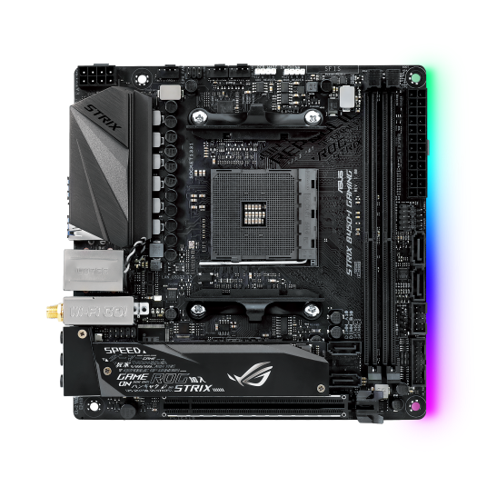

Image: ASUS ROG Strix B450-I Gaming (product photo, source: <https://rog.asus.com/au/motherboards/rog-strix/rog-strix-b450-i-gaming-model>)

**AMD Ryzen 5 3600 6-core 12-thread 3.6GHz processor to AMD Ryzen 7 5700X 8-core 16-thread 3.4GHz processor, firmware compatibility & validation.**

Harrison Whitely, Swan View, whitely.harrison@gmail.com

13th of August 2025 - v1.0

# Executive Summary

This document outlines the process of upgrading from an AMD Ryzen 5 3600 to a Ryzen 5700X on an ASUS ROG Strix B450-I Gaming motherboard, including the required BIOS update for compatability. The upgrade was completed successfully with stable post installation performance, validated through stress testing and temperature monitoring. This guide documents the compatibility checks, precautions, and step by step procedure to ensure a safe and reliable upgrade.

**Table of Contents**

Executive Summary 2

Bill of Materials & Versions 4

Compatibility & Risk Checks 5

Procedure 8

BIOS Update 8

CPU Swap 10

Validation & Results 12

Lessons Learned 13

Appendix 14

# Bill of Materials & Versions

|  |  |
| --- | --- |
| **Item** | **Details** |
| Motherboard | ASUS ROG Strix B450-I Gaming |
| Old CPU → New CPU | Ryzen 5 3600 → Ryzen 7 5700X |
| Previous BIOS Ver. → Updated BIOS Ver. | 3004 → 5602 |
| BIOS file name and size | ROG-STRIX-B450-I-GAMING-ASUS-5602.CAP (16.8MB) |
| Vendor CPU Support Page | <https://www.asus.com/au/support/> |
| PSU/Cooler | Corsair RM650x / Noctua NH-U12S |

# Compatibility & Risk Checks

* Verified Ryzen 7 5700X support on Asus's official CPU compatibility list and verified checksum.
* Erased any data on USB and partitioned to FAT32 format.
* Downloaded latest BIOS version from vendors official site.
* Prepared FAT32 USB stick with BIOS file.
* Backed up BIOS settings by profile export and photos of critical settings.
* Ensured stable power by connecting system to a surge-protected outlet.

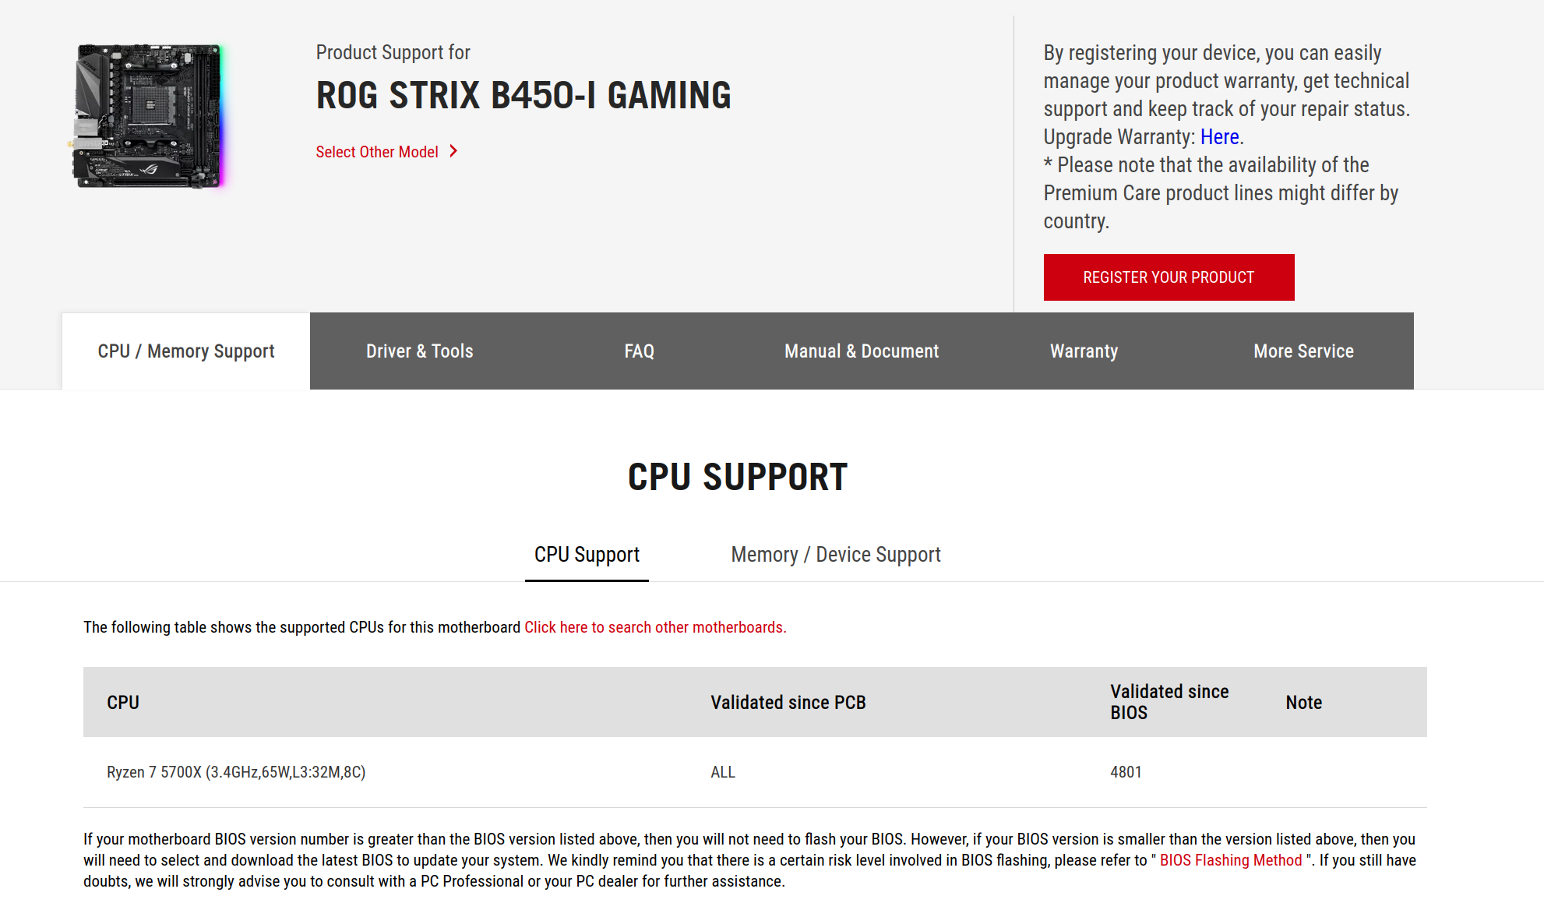

(Screenshot:***Figure 1*** *- Motherboard support for new CPU*)

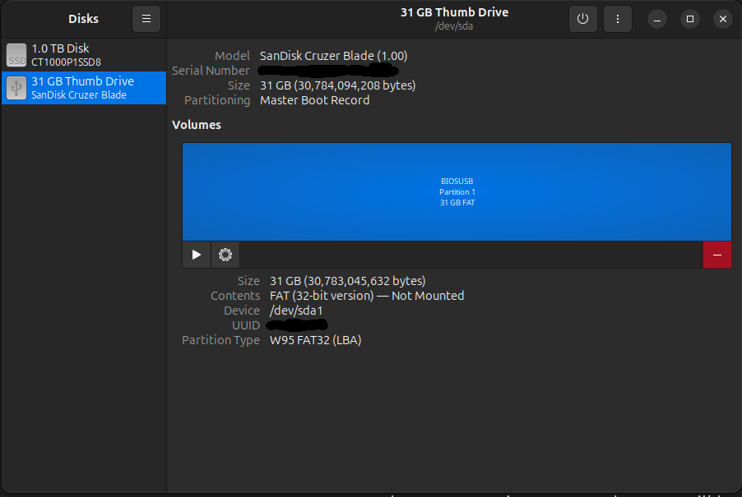(Screenshot:***Figure 2*** *- USB data erased and partitioned to FAT32 format*)

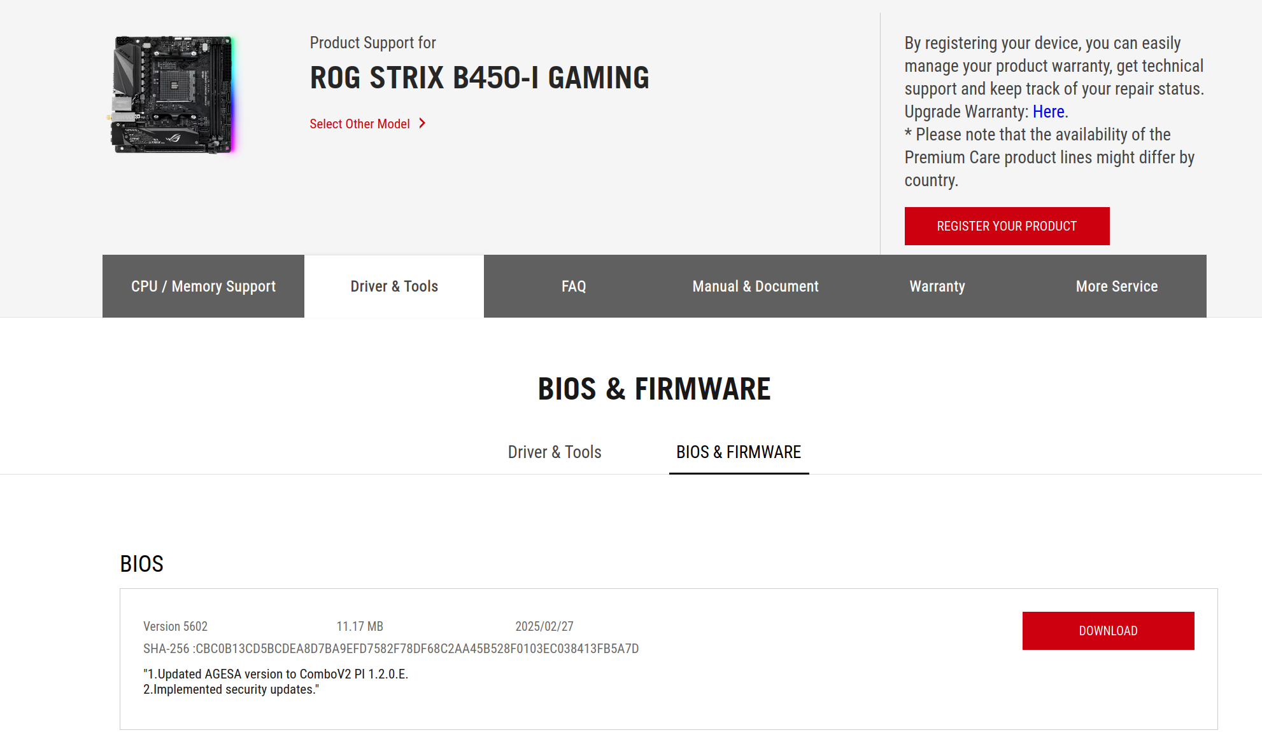(Screenshot:***Figure 3*** *- Latest BIOS version from ASUS website*)

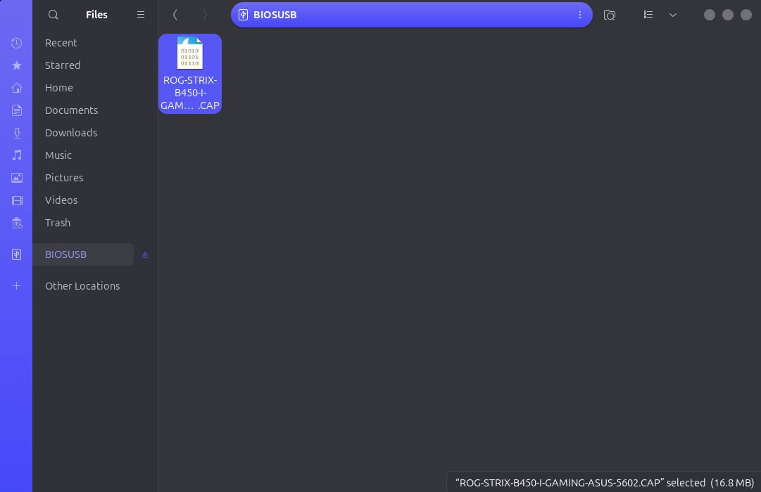(Screenshot:***Figure 4*** *- BIOS file only (.cap) moved onto USB*)

# Procedure

## BIOS Update

1. Boot into BIOS (keep pressing DEL key).
2. Open EZ Flash 3 utility.
3. Select *ROG-STRIX-B450-I-GAMING-ASUS-5602.CAP* file from USB, confirm.
4. Wait until system reboots and completes flash.
5. Verify version is 5602 in BIOS.

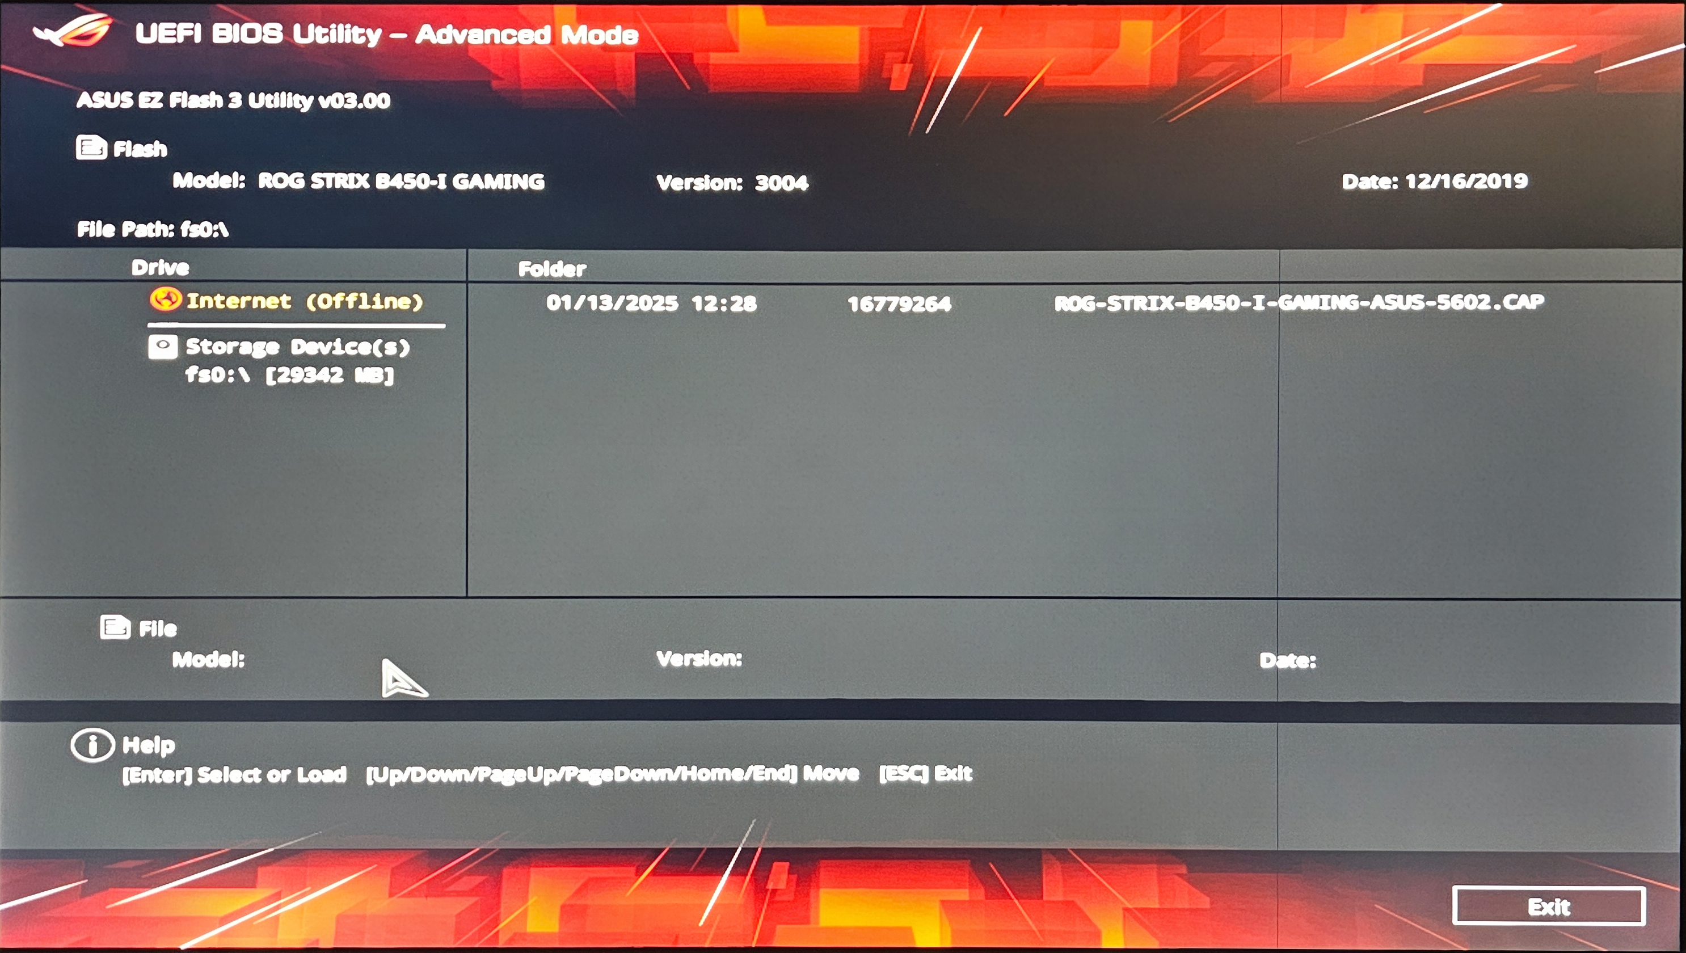(Photo:***Figure 5*** *- EZ Flash 3 in BIOS, showing the USB with .cap file*)

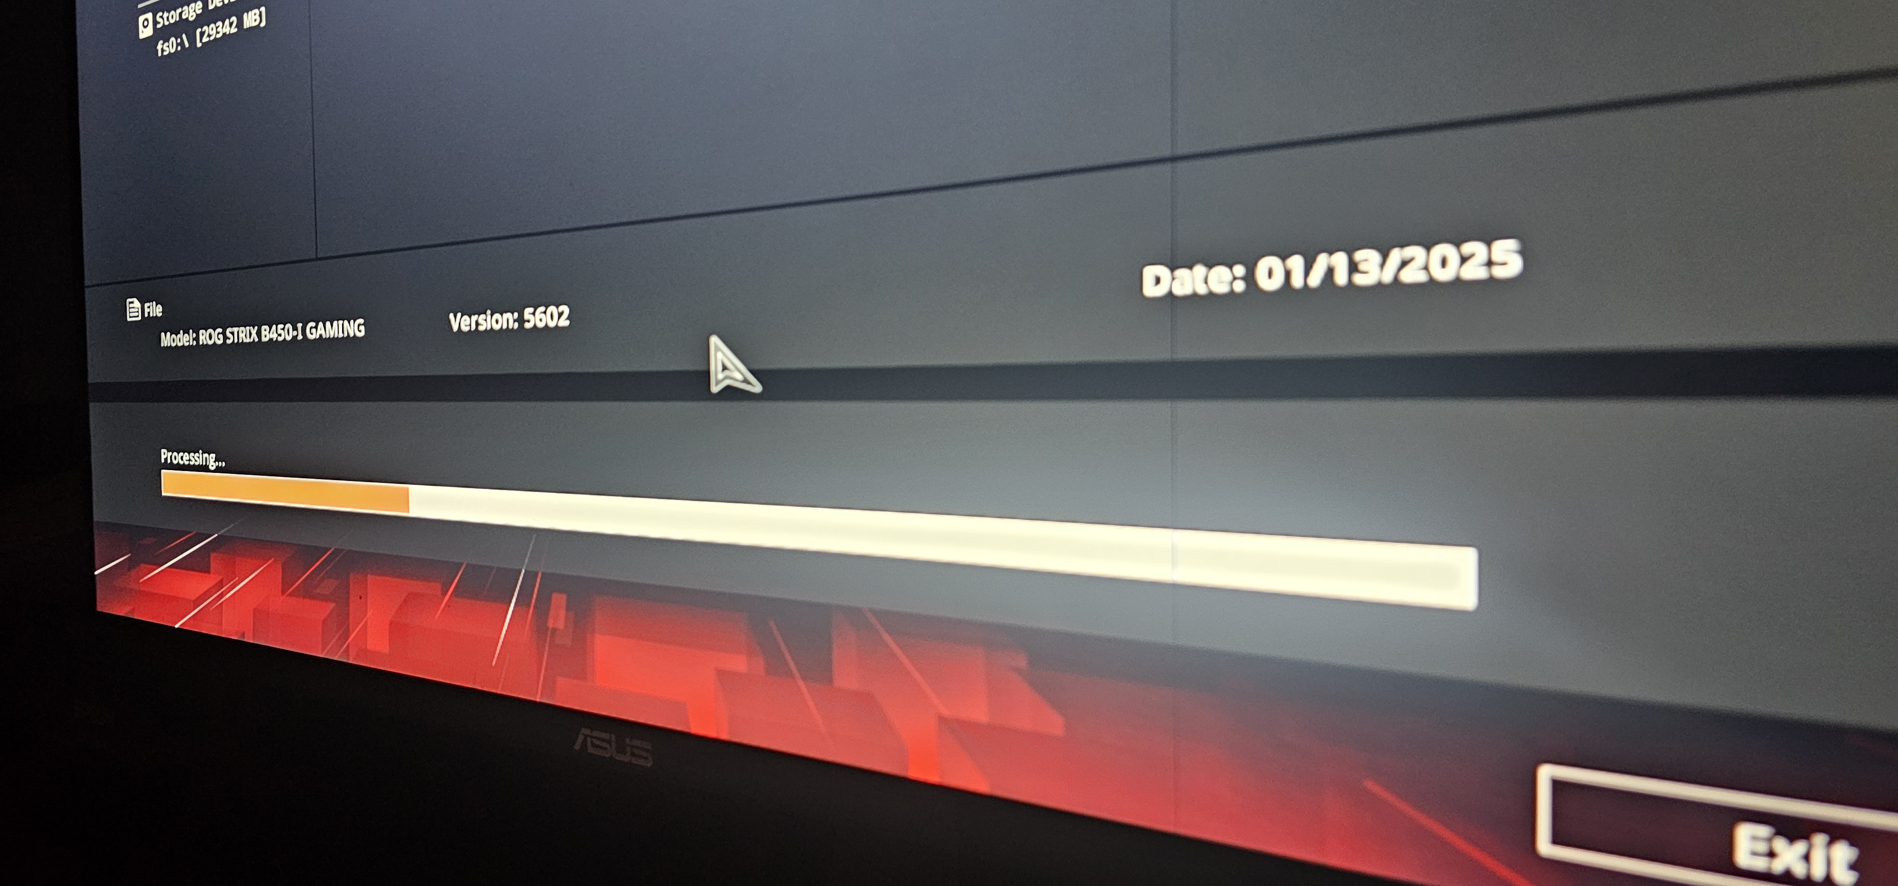(Photo:***Figure 6*** *- BIOS update in progress*)

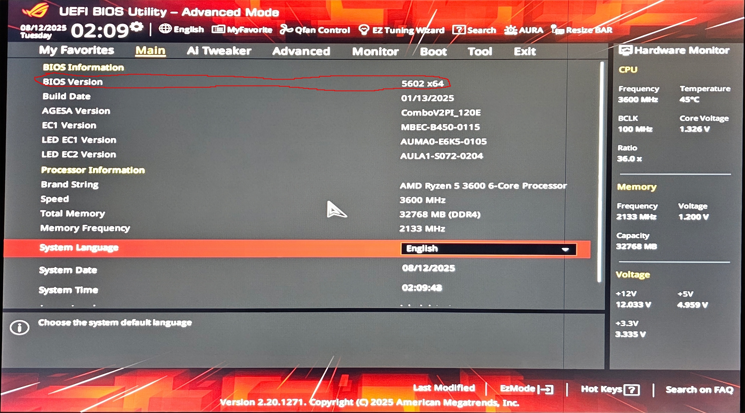(Photo:***Figure 7*** *- BIOS version 5602 confirmed*)

## CPU Swap

1. Shut down PC, unplug, and discharge static.
2. Remove cooler and CPU, clean both with isopropyl alcohol and with a lint-free cloth.
3. Install new CPU, apply a pea size amount of thermal paste, re-mount cooler.
4. Boot into BIOS again, verify new CPU is detected and temperature is stable and within acceptable range.

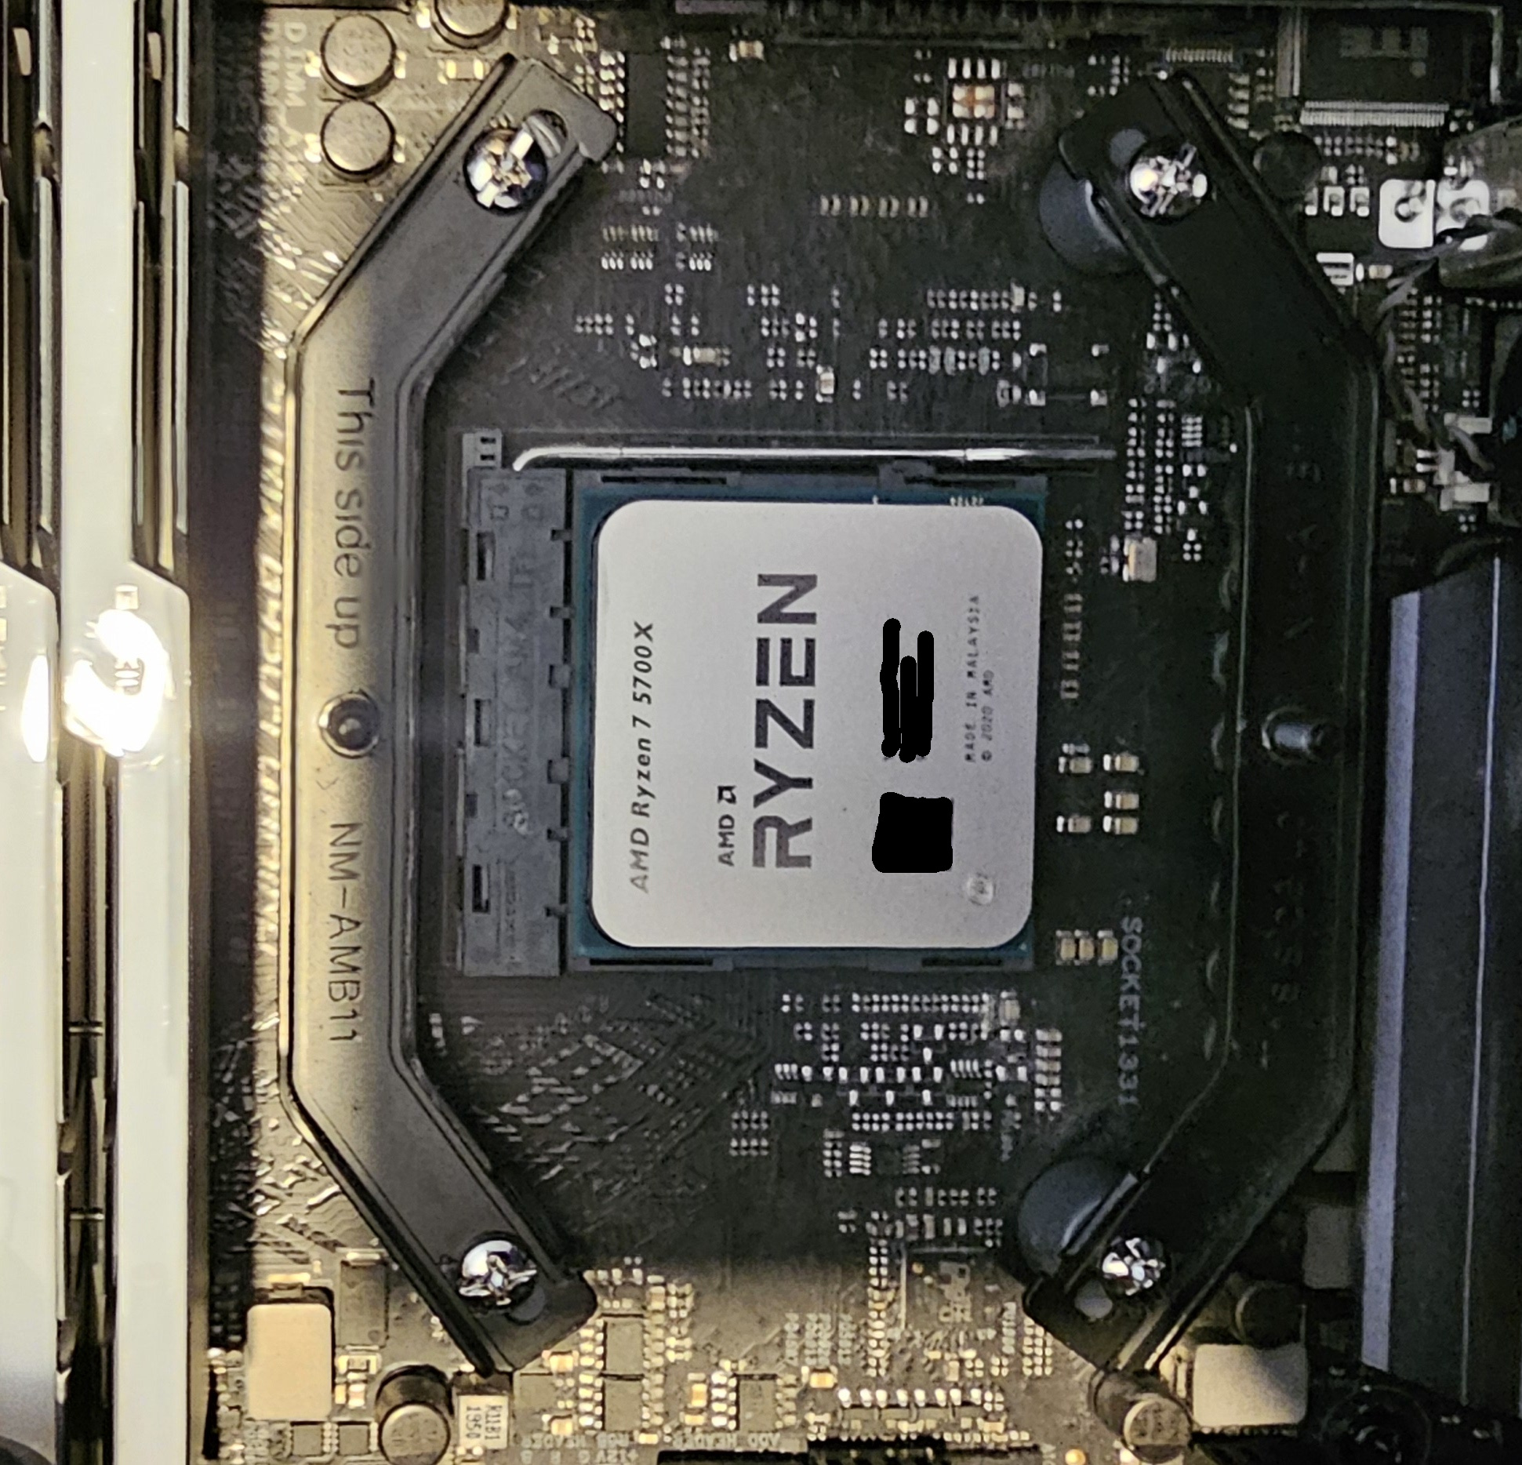

(Photo:***Figure 8*** *- New CPU installed*)

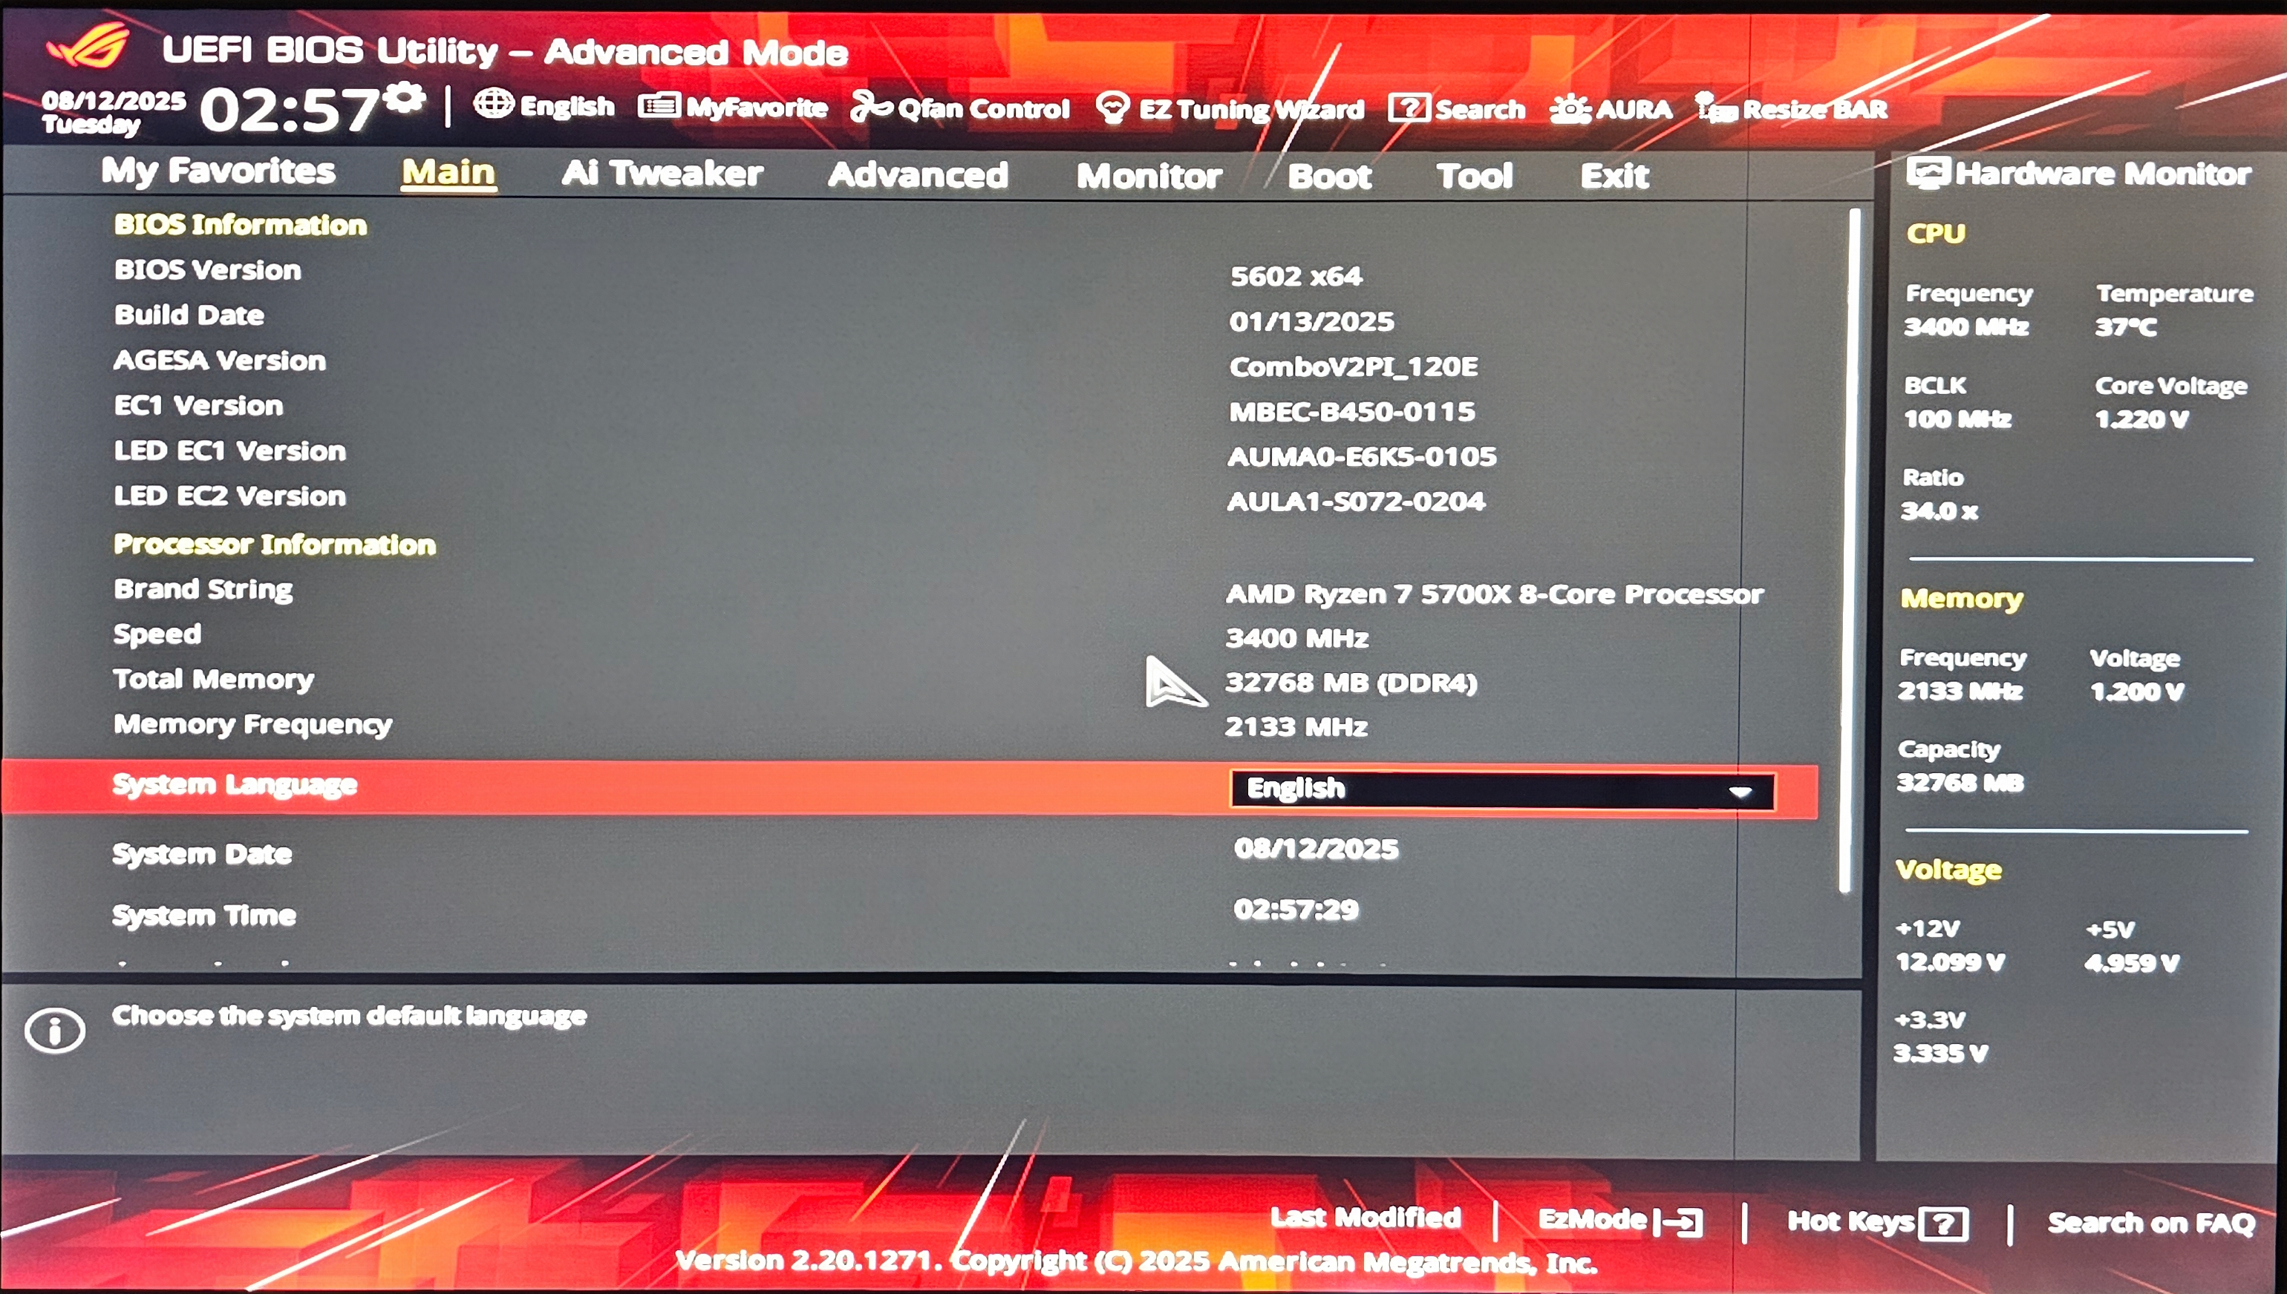(Photo:***Figure 9*** *- BIOS confirms new CPU and stable temperature*)

# Validation & Results

|  |  |
| --- | --- |
| **Check** | **Result** |
| BIOS version shows 5062 | Pass |
| CPU detected as Ryzen 7 5700X | Pass |
| Idle temperature | 37ºC |
| Load temperature | 68ºC |
| Stress test (15 mins) | Pass |

All validation checks passed, with stable temperatures and no throttling. The system successfully booted into Ubuntu and completed a 15-minute CPU stress test without errors.

# Lessons Learned

* Always verify CPU compatibility before purchase.
* Back up BIOS settings before flashing.
* Keep a stable power source during firmware updates.
* Reseat RAM if system fails to boot after cooler removal.
* If the system fails to boot, clear CMOS via jumper or battery removal.

# Appendix

Useful Links

* [ASUS ROG Strix B450-I Gaming Latest BIOS Download](https://rog.asus.com/au/motherboards/rog-strix/rog-strix-b450-i-gaming-model/helpdesk_bios/)
* [ASUS CPU Compatibility List](https://rog.asus.com/au/motherboards/rog-strix/rog-strix-b450-i-gaming-model/helpdesk_cpu/)

Checksums

* ROG-STRIX-B450-I-GAMING-ASUS-5602.CAP - SHA256: CBC0B13CD5BCDEA8D7BA9EFD7582F78DF68C2AA45B528F0103EC038413FB5A7D

Extra Notes

* Screenshots cropped for clarity.
* All images containing serial numbers or keys were redacted.
* Ubuntu 24.04.3 used as the testing environment.
* Psensor used to check temperature during stress test.  
  Command used: *watch -n 1 sensors*
* stress-ng used to stress test CPU.  
  Command used: *stress-ng --cpu 8 --timeout 900s*